**Configure Tomcat on Windows Server 2016**

**Create a virtual machine - Windows Server 2016 Datacenter**

- Enable RDP, HTTP

**Connect via RDP**

**Install JRE**

<https://www.oracle.com/technetwork/java/javase/downloads/jre8-downloads-2133155.html>

**Install Tomcat Server**

<http://apachemirror.wuchna.com/tomcat/tomcat-7/v7.0.96/bin/apache-tomcat-7.0.96.exe>

**Configure JRE Path**

C:\Program Files\Java\jre1.x.x_xxx

**Start Tomcat Server**

**Open Browser type http://localhost:8080/** -> sample Tomcat Server page will be there

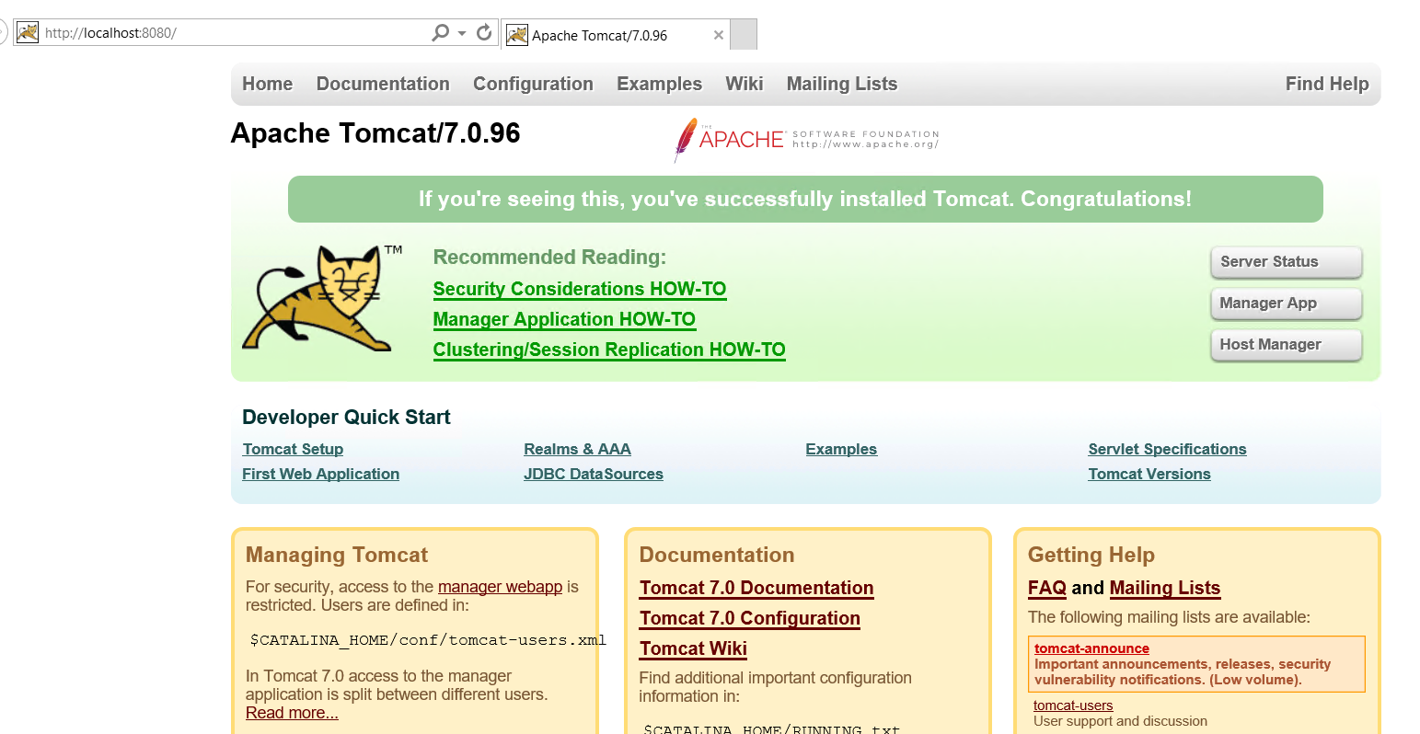

**Open Port in Firewall**

Open **Control Panel** and Select **Windows Firewall** option

Select **Advanced Settings** option

Click on Inbound Rules and add new Rule

[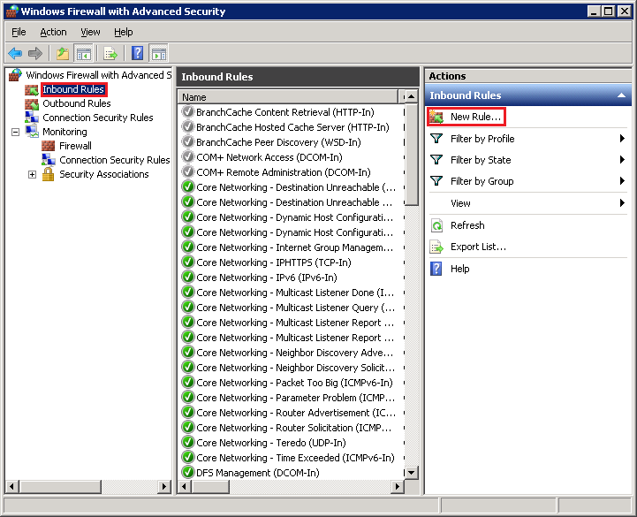](https://github.com/uglide/azure-content/blob/master/articles/virtual-machines/media/virtual-machines-windows-classic-java-run-tomcat-app-server/NewInboundRule.png)

For the **Rule Type**, select **Port**, and then click **Next**.

[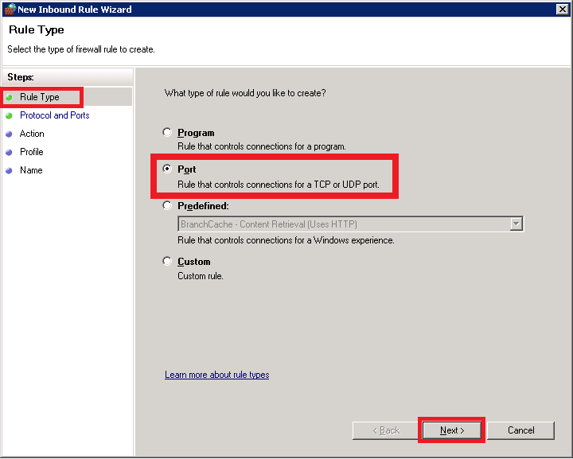](https://github.com/uglide/azure-content/blob/master/articles/virtual-machines/media/virtual-machines-windows-classic-java-run-tomcat-app-server/NewRulePort.png)

On the **Protocol and Ports** screen, select **TCP**, specify **8080** as the **Specific local port**, and then click **Next**.

[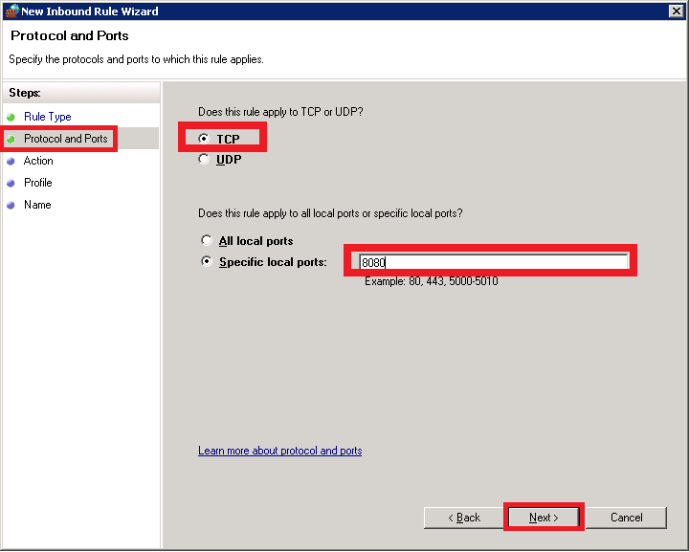](https://github.com/uglide/azure-content/blob/master/articles/virtual-machines/media/virtual-machines-windows-classic-java-run-tomcat-app-server/NewRuleProtocol.png)

On the **Action** screen, select **Allow the connection**, and then click **Next**.

[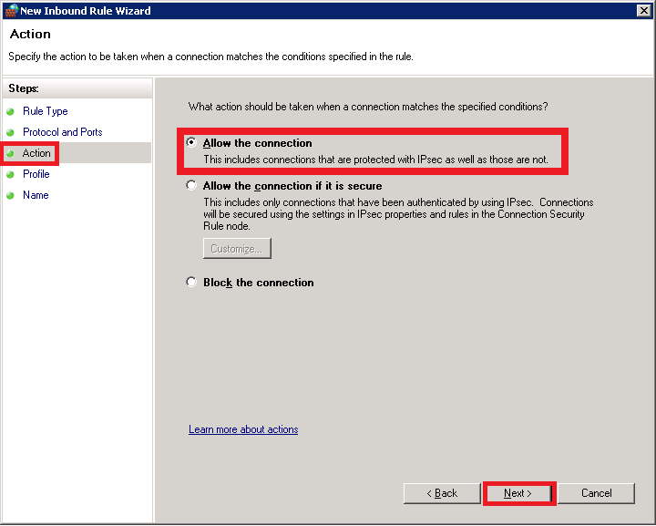](https://github.com/uglide/azure-content/blob/master/articles/virtual-machines/media/virtual-machines-windows-classic-java-run-tomcat-app-server/NewRuleAction.png)

On the **Profile** screen, ensure that **Domain**, **Private**, and **Public** are selected, and then click **Next**.

[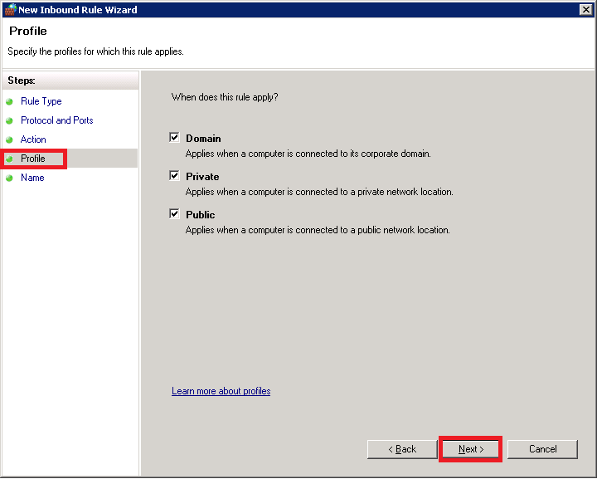](https://github.com/uglide/azure-content/blob/master/articles/virtual-machines/media/virtual-machines-windows-classic-java-run-tomcat-app-server/NewRuleProfile.png)

On the **Name** screen, specify a name for the rule, such as **HttpIn** (the rule name is not required to match the endpoint name, however), and then click **Finish**.

[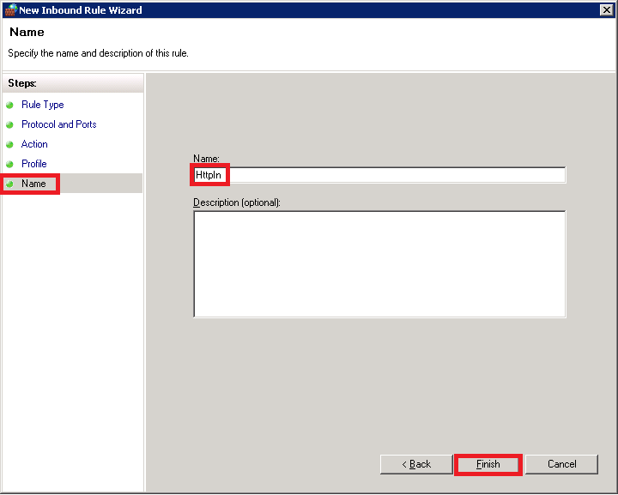](https://github.com/uglide/azure-content/blob/master/articles/virtual-machines/media/virtual-machines-windows-classic-java-run-tomcat-app-server/NewRuleName.png)

Navigate to Azure Portal

Add **Network inbound port rule**

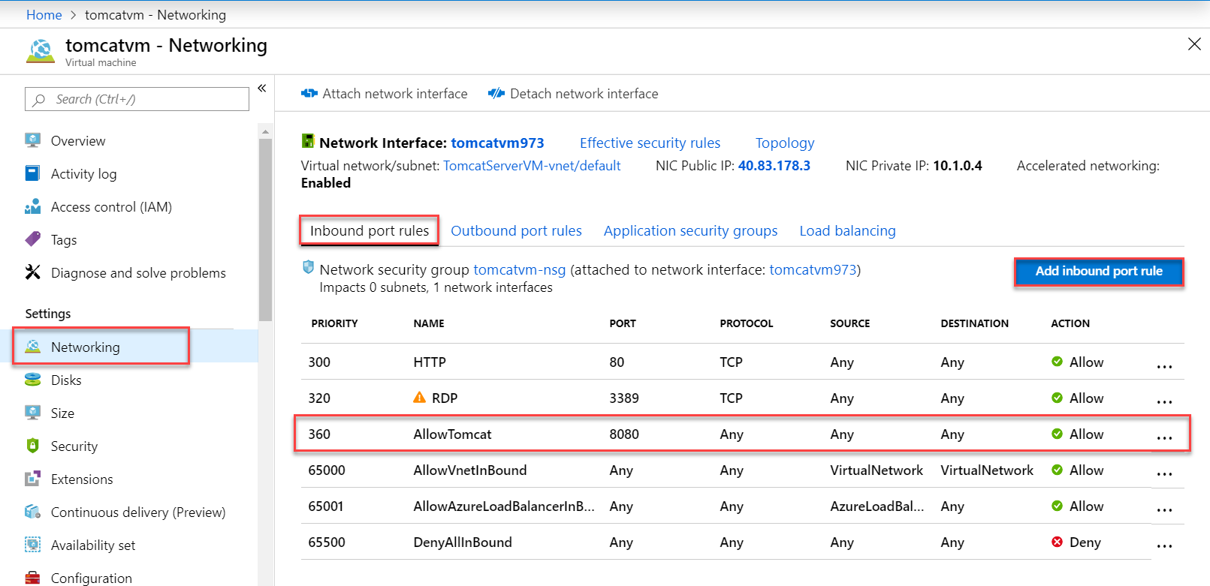

Open Virtual Machine Public IP address with 8080 port

Ex. 40.83.178.3:8080

